Revision History
- Rev A, John Bonnell, UCB SSL; 19 May 2010, 4 Jun 2010.
  - Initial version, developed in response to request from RBSP GNC for example EFW MAG (APID 0x245) data file.

TN-038. EFW-MAG Data Example Description

Summary
The analog data from the EMFISIS-MAG sensor is provided to the EFW IDPU and is utilized by the EFW on-board digital signal processing to produce waveforms in magnetic-field-aligned coordinates for spectral analysis. This data can also be telemetered to the ground, and that data path can be used as an alternate source of MAG data if the EMFISIS MEB is disabled in flight.

In order to verify the processing tools being developed to support this alternate MAG data path, the RBSP GNC team requested example EFW MAG (APID 0x245) data to work with. Below, we describe general features and particular events in each of the example files provided by EFW to Project GNC.

General Notes

The data files are provided in the PTP fiel format, fully-described in the RBSP MOC-SOC ICD [DOC-REF].

Info about non-EFW elements of the PTP files (GA and GDH elements); not relevant to general decommutation of data file contents at this time.

During Instrument INT, EFW is using a simplified MET convention. The MET provided by the spacecraft emulator (SCE) is reset to the current UTC date and time in seconds since 00:00:00 01-01-1970 UTC (so-called UNIX time). Examples of MET to DATE/TIME conversions shown directly below for the first four packets in the file:

MET  [s, UNIX Time] | UTC Date/Time  [YYYY-MM-DD/HH:MM:SS)
1272584725 | 2010-04-29/23:45:25
1272584741 | 2010-04-29/23:45:41
1272584757 | 2010-04-29/23:45:57
1272584773 | 2010-04-29/23:46:13

Contents of the PTP should be homogeneous with respect to APID (all APID 0x245).

File does not implement the “Stale MAG range” flag currently under discussion.

Example 1: 20100429_164317_UUT99_APID_245.ptp

File Size: ~12.4 MB.

Number of Packets: 4212.
MET of first packet: 1272584725
MET of last packet: 1272652266

Number of samples: 2,156,544.
Time of first sample [UTC]: 2010-04-29/23:45:25.580.
Time of last sample [UTC]: 2010-04-30/18:31:22.693.

Instrument Configuration:
Sampling Rate: 64 samp/s.
Enabled Channels: MAGX, MAGY, MAGZ.

This is a fairly vanilla EFW MAG data file to get started upon. There are some gaps in the data coverage that arise from changes to other EFW data products, but there are no changes in the instrument configuration (sample rate or enabled channels) over the entire run of data.

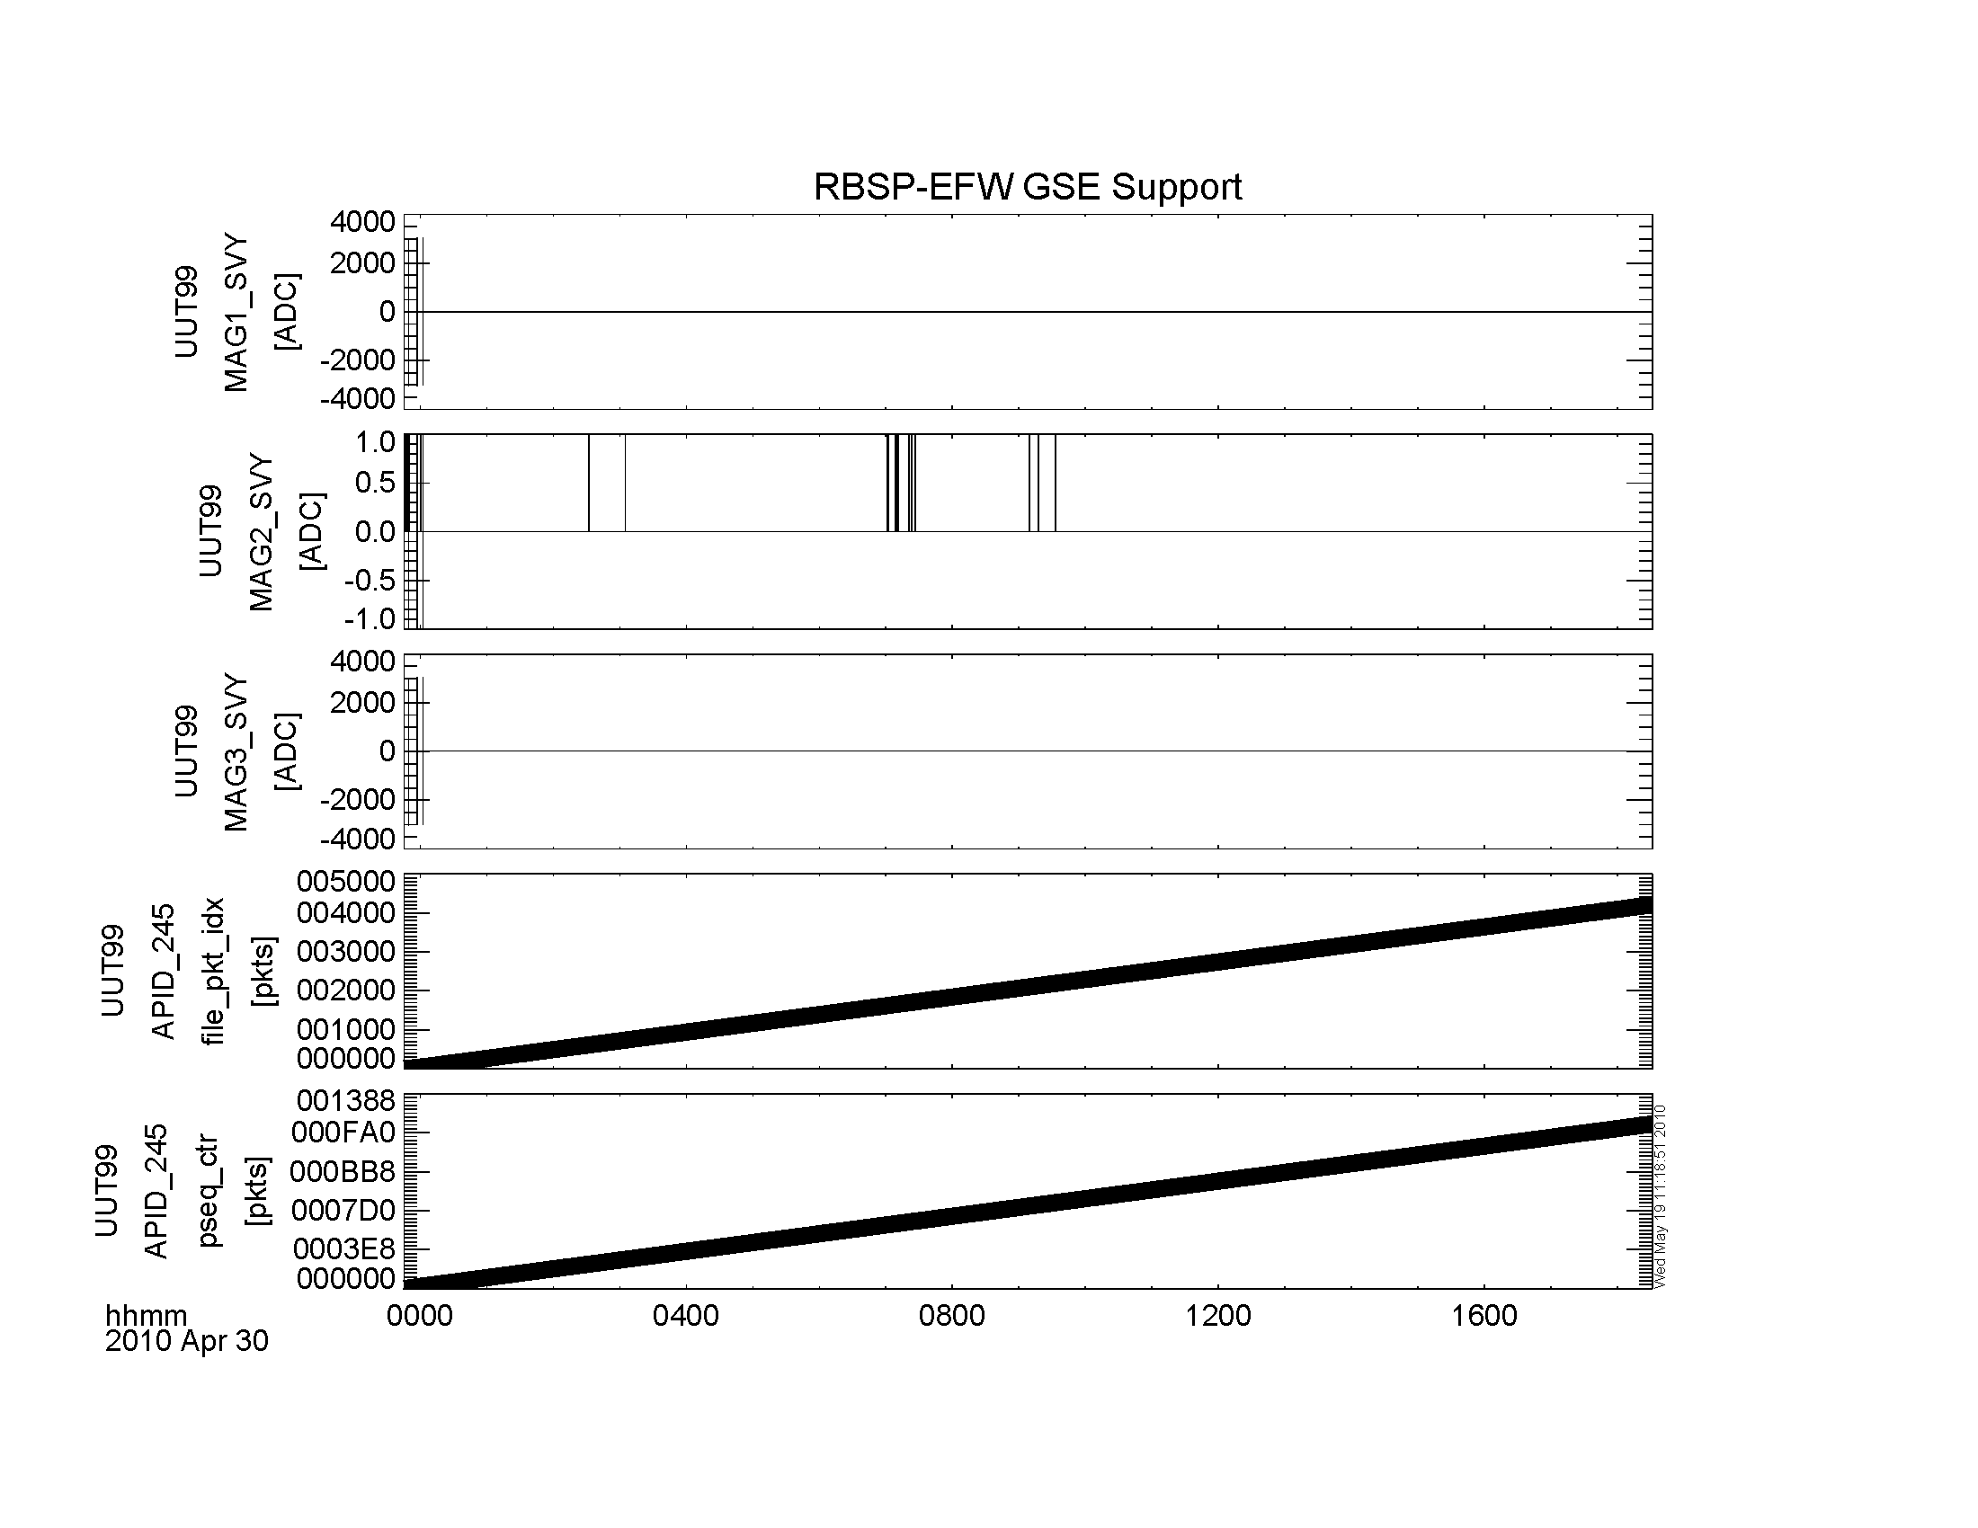
Figure 1: Summary Plot of Example 1. Top three panels are MAGX, MAGY, and MAGZ in ADC units; panel 4 is the packet number in the file; panel 5 is the Packet Sequence Counter from the CCSDS header.

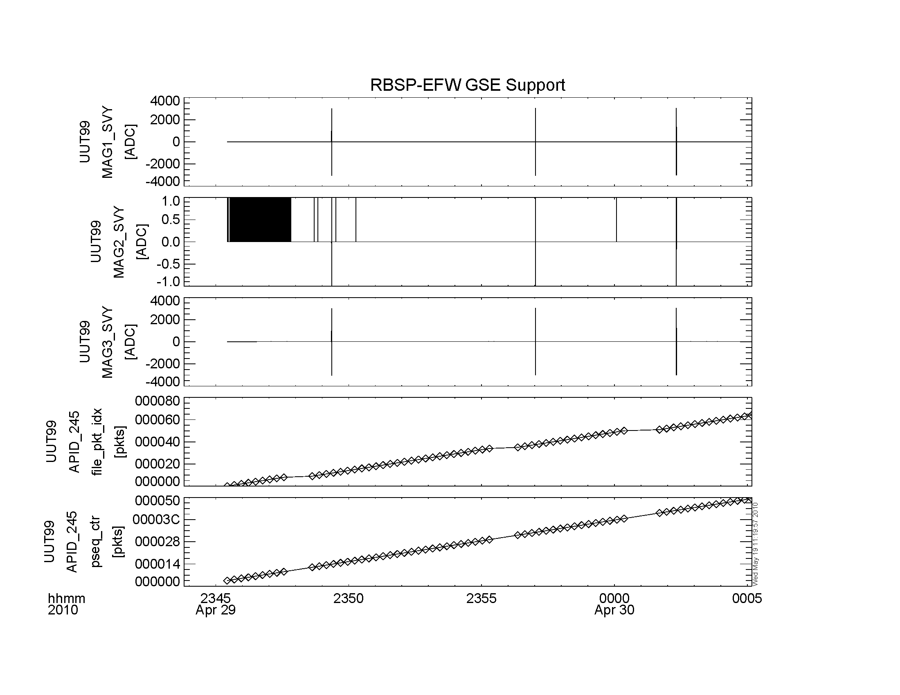
Figure 2: Zoom in to initial 20-minute stretch of example data, containing three tone bursts triggered from the 1PPS signal. Analog signals were applied to MAG1 and MAG3 analog inputs of the EFW DFB; MAG2 input was hard-grounded to AGND.

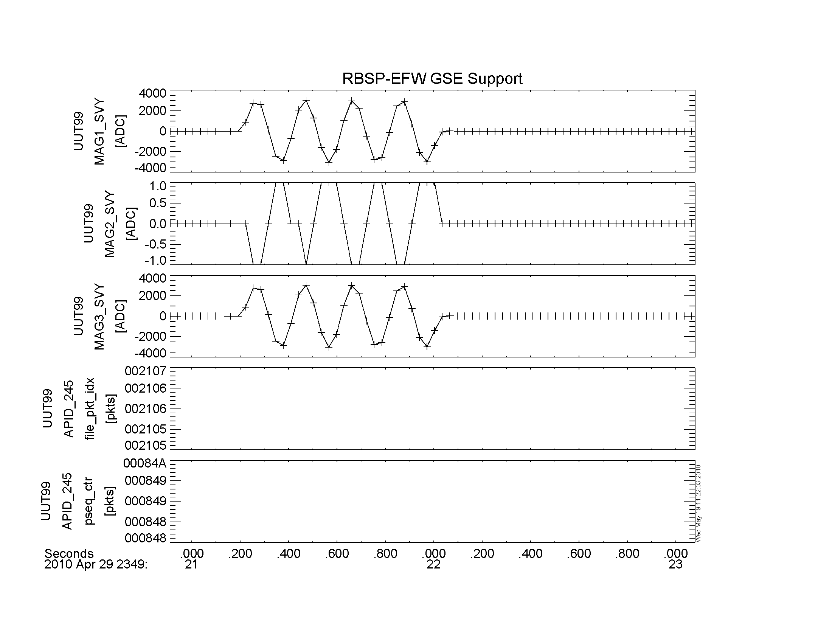
Figure 3: Tone Burst 1 -- four cycles of 5-Hz signal. Tone burst was applied to analog inputs at the MET 1PPS tick at 2010-04-29/23:49:21. Delay in response (~0.2 s) is due to finite analog and digitial signal processing delays on EFW DFB. Signal was applied to MAG1 and MAG3; signal on MAG2 is crosstalk (~1 part in 3000), possibly in analog test set up.

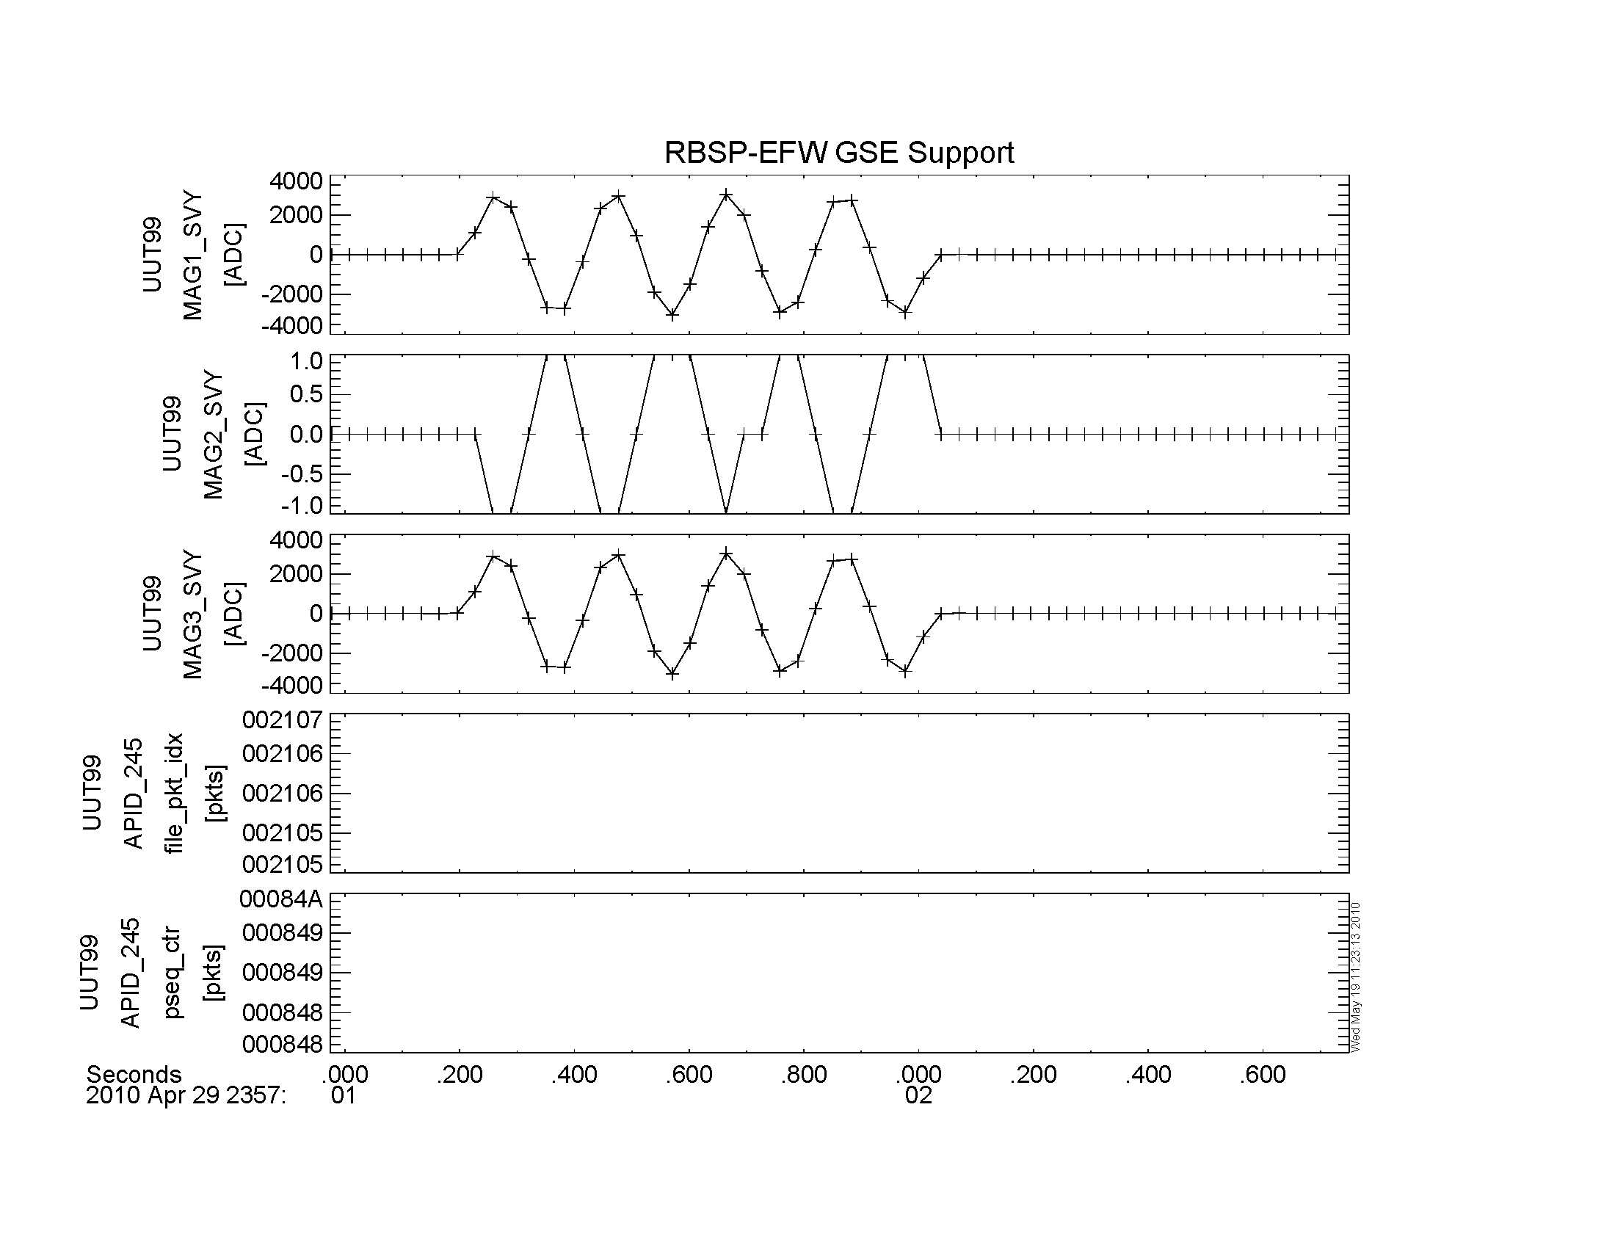
Figure 4: Tone Burst 2, same format as Tone Burst 1.

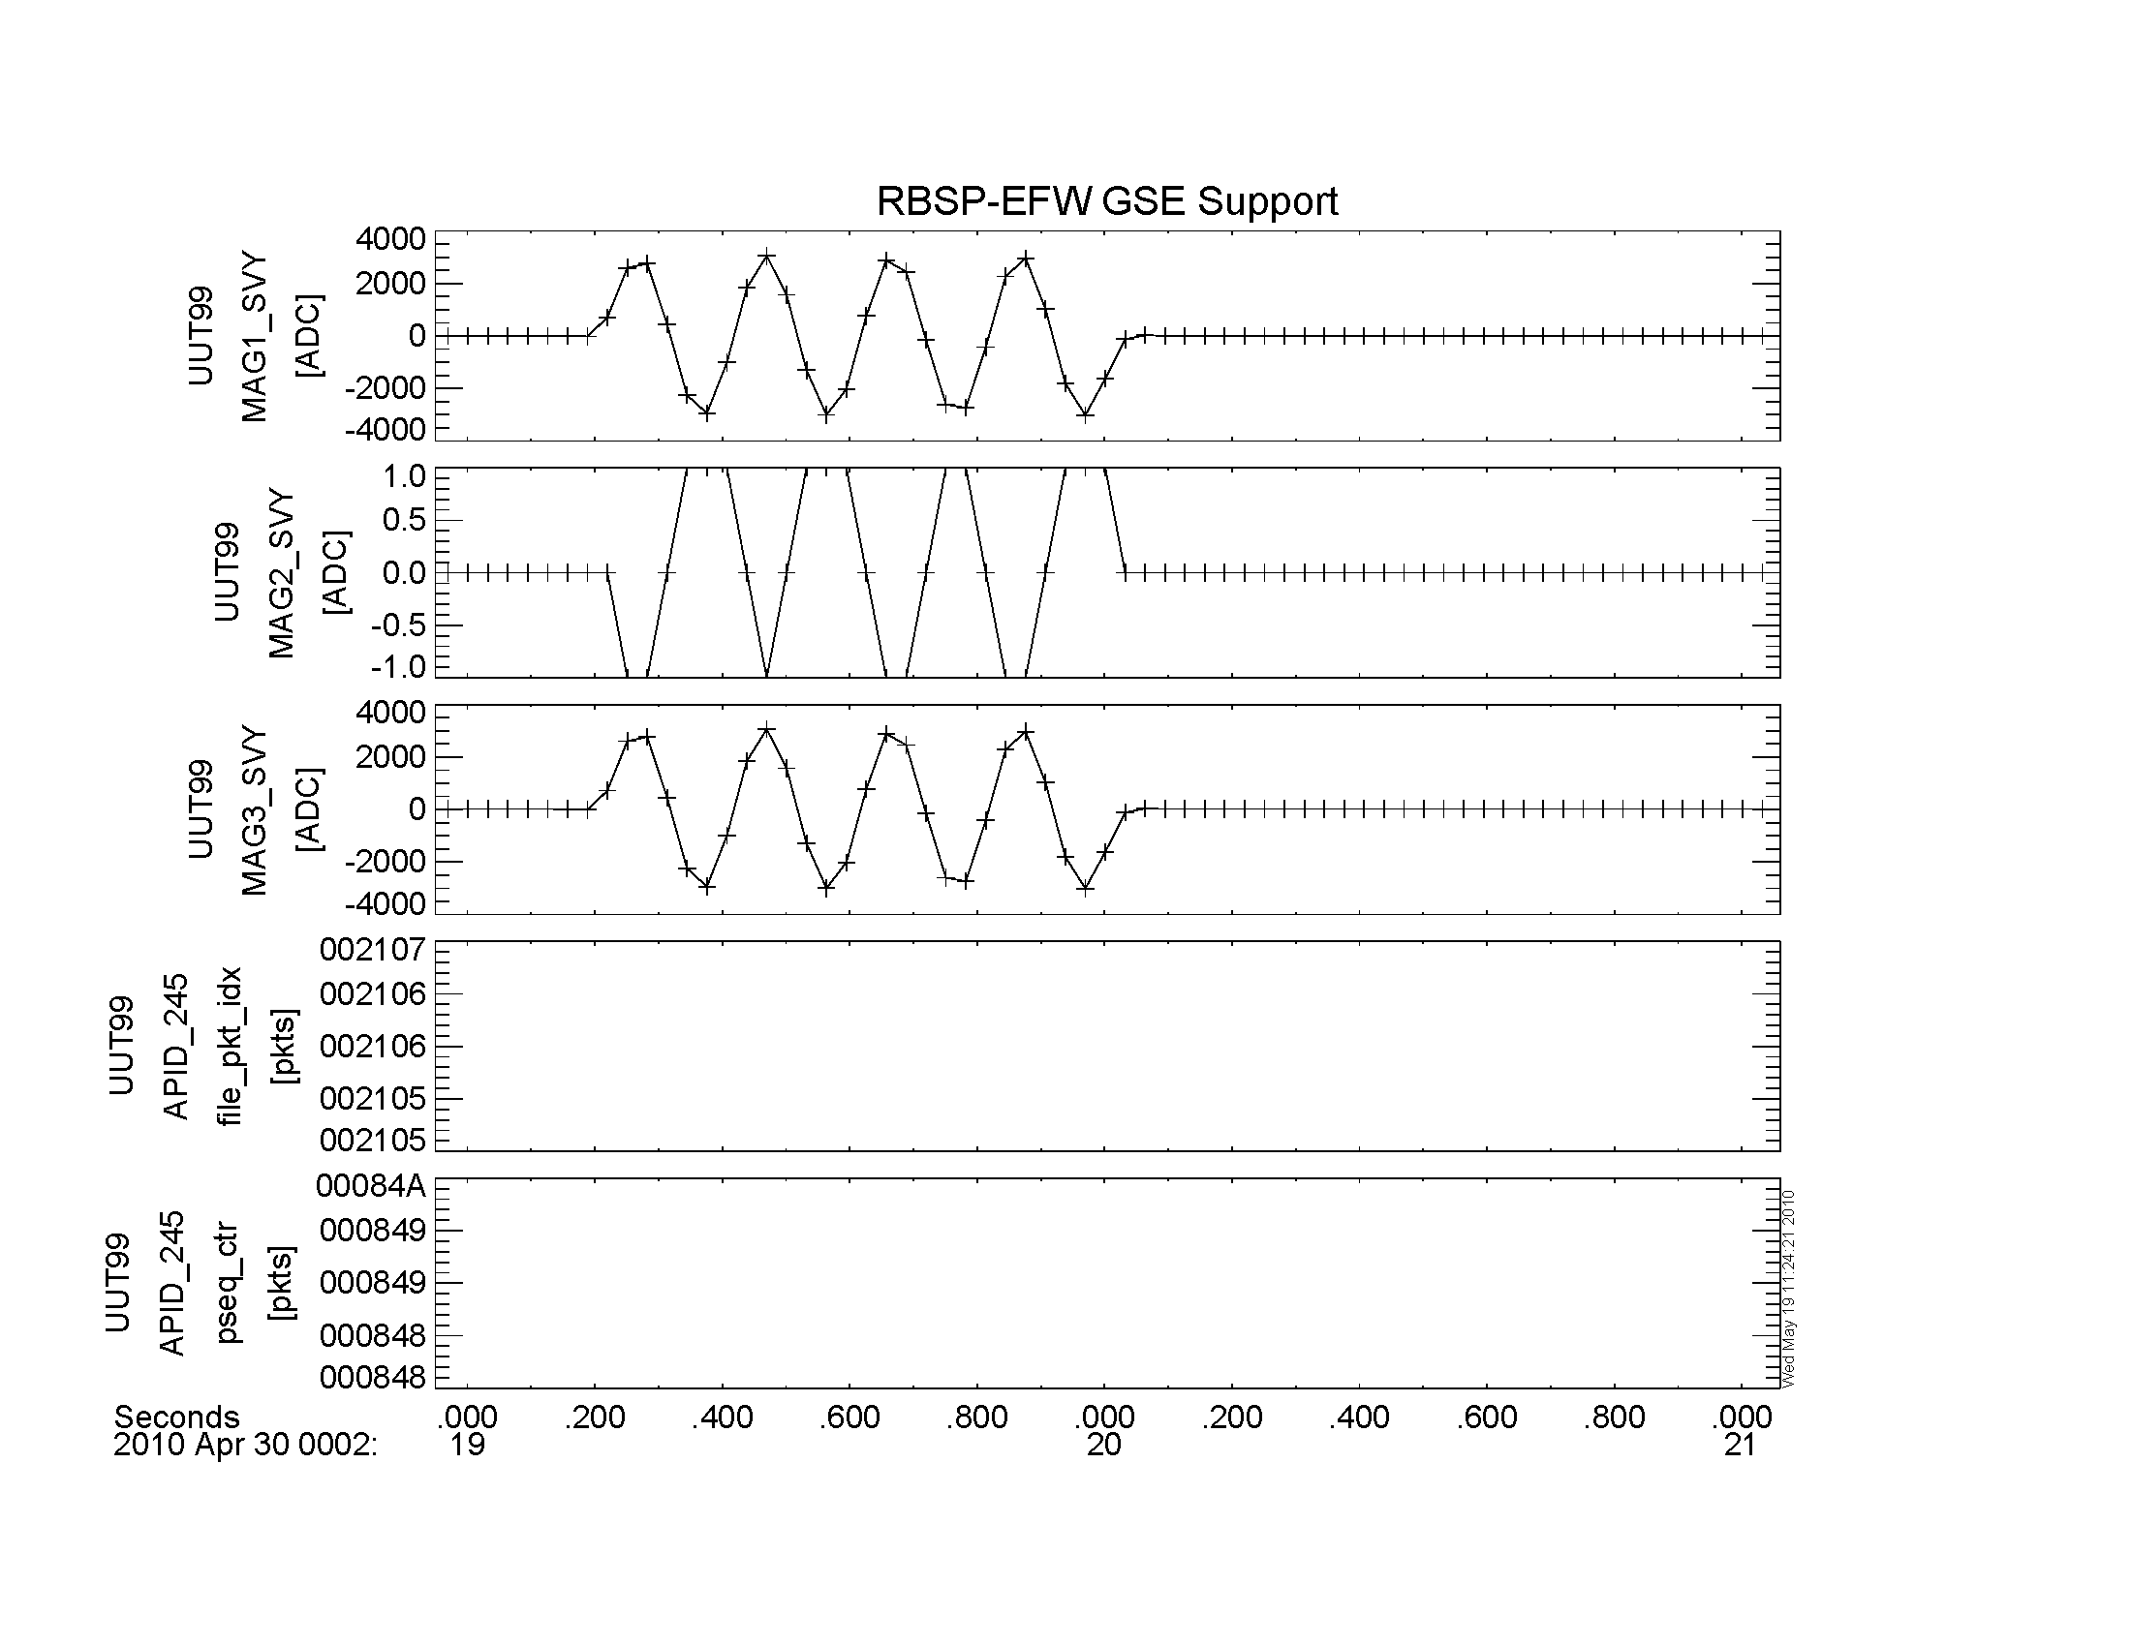
Figure 5: Tone Burst 3, same format as Tone Burst 1.

Example N: TBD.

Closing Remarks
TBD.

